|  |  |
| --- | --- |
| **YEAR 8** | **Energy Transfer & Transformation** |

|  |  |
| --- | --- |
| **Learning Intentions** | **Success Criteria** |
| Understand the transfer and transformation of energy. | * Describe how energy can be transferred, transformed, stored and wasted. * Describe the law of conservation of energy and relate this to energy transfer. * Interpret and create energy flow diagrams. |

**WATCH:** *The Swinging Ball of Death*

|  |  |
| --- | --- |
| File:Logo of YouTube (2015-2017).svg - Wikipedia | Watch this YouTube video:  <https://www.youtube.com/watch?v=EZNpnCd4ZBo> |

**READ:** *Law of Conservation of Energy*

The **law of conservation of energy** states:

*“Energy cannot be created or destroyed, only transferred from one state to another”.*

This means that:

* Energy might be passed on or wasted, but it is never lost.
* If one object wastes energy, then it is always gained by another object, usually as heat.

**WATCH:** *Physics Rollercoaster*

|  |  |
| --- | --- |
| File:Logo of YouTube (2015-2017).svg - Wikipedia | Watch this YouTube video:  <https://www.youtube.com/watch?v=LrRdKmjhOgw&t=82s> |

**READ:** *Energy Transfer & Transformation*

When energy is passed from one object to another it is called **energy transfer.**

Energy does not always stay in the same form. It can change from one type of energy into another. This process is called an **energy transformation.**

**Energy Flow Diagram for a Mobile Phone**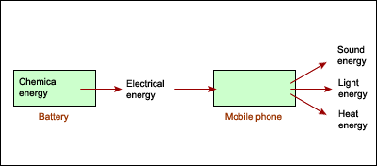

Image: <https://www1.curriculum.edu.au/sciencepd/energy/chg_flow.htm>

**Energy flow diagram:** Energy flow diagrams can illustrate how energy is transformed from one form of energy to other forms of energy.

**ACTIVITY 1:** *Transforming Energy*

**YOUR TASK:** Identify the energy output in each of the following examples. There may be more than one.

|  |  |  |
| --- | --- | --- |
| **Energy Converter** | **Starting (Input) Energy** | **Finishing (Output) Energy** |
| **Windup Toy** | Elastic potential energy |  |
| **Battery Powered Torch** | Chemical energy |  |
| **LED lamp** | Electrical energy |  |
| **Motor Car** | Chemical energy |  |

**ACTIVITY 2:** *Energy Flow Diagram*

**YOUR TASK:** Watch the following YouTube clip and construct an energy flow diagram from one food chain in the video in the space below.

|  |  |
| --- | --- |
| File:Logo of YouTube (2015-2017).svg - Wikipedia | Watch this YouTube video:  <https://www.youtube.com/watch?v=5jBV9vJmXZI> |

**READ:** *Input, Converter & Output Energy*

When we describe energy transformation we say there is:

* **Input energy:** The energy that is about to be transformed
* **Output energy:** The energy that the input energy has been transformed into
* **Converter:** The ‘thing’ that allowed the change to occur

*For example, a tree converts light energy from the sun into chemical energy via photosynthesis.*

**READ:** *Wasted Energy*

**Wasted** energy is not useful. It usually occurs in the form of heat.

**ACTIVITY 3:** *Input, Converter & Output Energy*

**YOUR TASK:** Identify the input energy, output energy and converters in each of the following examples.

|  |  |  |  |
| --- | --- | --- | --- |
| **Situation** | **Input Energy** | **Converter** | **Output Energy** |
| A car engine changes chemical energy to mechanical energy and heat energy |  |  |  |
| A tree changes radiant energy to chemical energy during photosynthesis |  |  |  |
| Hammering a nail changes mechanical energy to deformation and heat energy |  |  |  |
| A thermonuclear reaction changes nuclear energy to radiant and heat energy |  |  |  |
| An electric motor changes electrical energy to mechanical and heat energy |  |  |  |
| A lamp changes electrical energy to radiant and heat energy |  |  |  |

**READ:** *Energy Efficiency*

**Energy efficiency:** Definition - A measure of how much input energy is converted into useful output energy. Efficiency is usually given as a percentage.

The greater portion of useful output energy, the greater the energy efficiency of the device.

If most of the input energy is converted into useful output energy (i.e. not much energy is wasted), then the device is energy efficient.

**Diagram: The energy efficiency of a typical halogen light bulb**

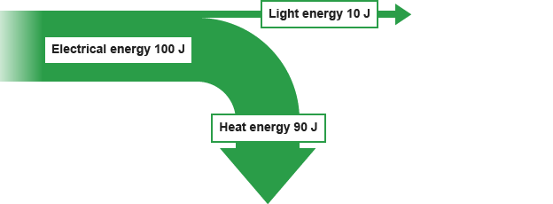

**Image:** <https://www.bbc.co.uk/bitesize/guides/zgvc6fr/revision/4>

**ACTIVITY 4:** *Energy Efficient House*

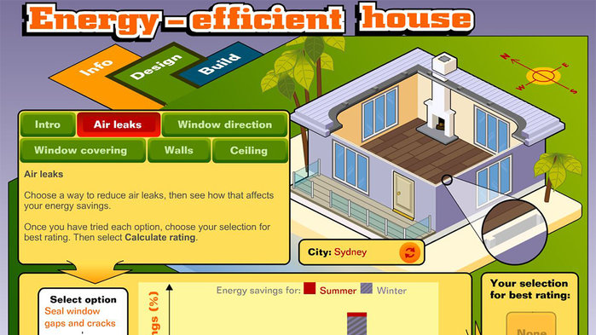

**Image:** <https://education.abc.net.au/home#!/media/1497537/energy-efficient-house> (Creative Commons)

**Visit the following website and run the energy efficient house interactive**

<https://education.abc.net.au/home#!/media/1497537/energy-efficient-house>

**YOUR TASK:** Consider how you could design a house to be energy efficient.

|  |  |  |
| --- | --- | --- |
| **Question** | **Design Choice** | **Reason for your choice** |
| What colour would your house be? |  |  |
| What would your house be made of? |  |  |
| What direction would your house face? |  |  |
| How would you design your windows? |  |  |
| How would you design your doors? |  |  |
| How would you design your roof? |  |  |
| What other features might you include? |  |  |

Rate your understanding of energy transfer & transformation:  
 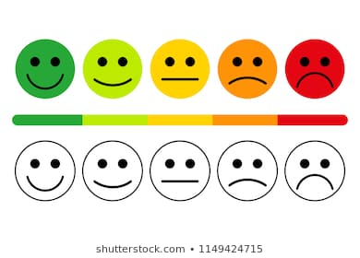

**[WARNING]**

Some of this material may have been copied [and communicated to you] in accordance with the statutory licence in section 113P of the Copyright Act. Any further reproduction or communication of this material by you may be the subject of copyright protection under the Act. Do not remove this notice.

These resources have been made available by the Department of Education Western Australia in response to COVID-19 on 22/04/2020 for your educational purposes. Do not distribute these resources for any other purpose.